 **INTEGRATED RESORT BOOKING**

**FOR VOYAGE**

**A DESIGN PROJECT REPORT**

***submitted by***

DHARSHINI S S

DHEETSHIKA R

GAYATHRI M

***in partial fulfilment for the award of the degree***

***of***

**BACHELOR OF ENGINEERING**

***in***

**COMPUTER SCIENCE AND ENGINEERING**

**K RAMAKRISHNAN COLLEGE OF TECHNOLOGY**

**(An Autonomous Institution, affiliated to Anna University Chennai, Approved by AICTE, New Delhi)**

**Samayapuram – 621 112 November, 2024 INTEGRATED RESORT BOOKING FOR VOYAGE**

### A DESIGN PROJECT REPORT

***submitted by***

DHARSHINI S S (811722104030)

DHEETSHIKA R(811722104032)

GAYATHRI M(811722104042)

***in partial fulfilment for the award of the degree***

***of***

**BACHELOR OF ENGINEERING**

***in***

**COMPUTER SCIENCE AND ENGINEERING**

**K RAMAKRISHNAN COLLEGE OF TECHNOLOGY**

**(An Autonomous Institution, affiliated to Anna University Chennai, Approved by AICTE, New Delhi)**

**Samayapuram – 621 112 November, 2024**

i

**BONAFIDE CERTIFICATE**

Certified that this project report titled **“INTEGRATED RESORT BOOKING FOR VOYAGE”** is bonafide work of **DHARSHINI S S(811722104030) , DHEETSHIKA R(811722104032), GAYATHRI M(811722104042)** who carried out the project under my supervision. Certified further, that to the best of my knowledge the work reported here in does not form part of any other project report or dissertation on the basis of which a degree or award was conferred on an earlier occasion on this or any other candidate.

**SIGNATURE SIGNATURE**

Dr A Delphin Carolina Rani M.E.,Ph .D Dr C Shyamala M.E.,Ph.D

HEAD OF THE DEPARTMENT SUPERVISER

PROFESSOR ASSOCIATE PROFESSOR

Department of CSE Department of CSE

K Ramakrishnan College of Technology K Ramakrishnan College of Technology

(Autonomous) (Autonomous)

Samayapuram-621 112 Samayapuram-621 112

Submitted for the viva-voice examination held on ………………

**INTERNAL EXAMINER EXTERNAL EXAMINER**

ii

### DECLARATION

We jointly declare that the project report on **“INTEGRATED RESORT BOOKING FOR VOYAGE ”** is the result of original work done by us and best of our knowledge,

similar work has not been submitted to **“ANNA UNIVERSITY CHENNAI”** for the requirement of Degree of Bachelor Of Engineering. This project report is submitted on the partial fulfilment of the requirement of the award of Degree of Bachelor Of Engineering.

#### Signature

DHARSHINI S S

DHEETSHIKA R

GAYATHRI M

Place : Samayapuram

Date :

iii

### ACKNOWLEDGEMENT

It is with great pride that we express our gratitude and indebtness to our

institution **“K RAMAKRISHNAN COLLEGE OF TECHNOLOGY”**, for providing us with the opportunity to do this project.

We are glad to credit honorable chairman **Dr. K RAMAKRISHNAN,**

**B.E.,** for having provided for the facilities during the course of our study in college. We would like to express our sincere thanks to our beloved Executive

Director **Dr. S KUPPUSAMY, MBA, Ph.D.,** for forwarding our project and offering adequate duration to complete it.

We would like to thank **Dr. N VASUDEVAN, M.Tech., Ph.D.,** Principal, who gave opportunity to frame the project with full satisfaction.

We whole heartily thank **Dr. A DELPHIN CAROLINA RANI, M.E., Ph.D.,** Head of the Department, **COMPUTER SCIENCE AND ENGINEERING** for providing her support to pursue this project.

We express our deep and sincere gratitude and thanks to our project guide

**Dr. C SHYAMALA, M.E.,Ph.D.,** Department of **COMPUTER SCIENCE AND ENGINEERING,** for her incalculable suggestions, creativity, assistance and patience which motivated us to carry our this project.

We render our sincere thanks to Course Coordinator and other staff members for providing valuable information during the course. We wish to express our special thanks to the officials and Lab Technicians of our departments who rendered their help during the period of the work progress.

iv

**ABSTRACT**

The **Project Tour Management System** is designed to streamline and enhance the experience of managing and booking tours. This system integrates a variety of essential features aimed at both users and administrators to ensure seamless interaction. The platform begins with a **s**ecurelogin functionality and user registration process, allowing users to create and manage their accounts efficiently. Upon successful registration, users can select their desired country for travel from a dynamic list of options. The system includes a payment detailing process where users can view and confirm their tour bookings, ensuring transparency in cost breakdowns.

Additionally, a currency converter feature is integrated to support international users by displaying tour prices in their preferred currency. All user interactions and data, including tour preferences, payment details, and selected countries, are securely stored and managed in a centralized database for easy access and retrieval. This architecture ensures data integrity, efficient retrieval, and enhances the overall user experience for managing tours and payments. This project aims to provide an intuitive, user-friendly platform to facilitate global tour bookings while managing different currencies and travel preferences effectively.

v

**TABLES OF CONTENTS**

**CHAPTER** **TITLE**

### PAGE NO

**ABSTRACT**  **v**

**LIST OF FIGURES**  **ix**

**LIST OF ABBREVIATIONS**

### 1 INTRODUCTION 1

1

1.1 Background

1

1.2 Overview

2

1.3 ProblemStatement

3

1.4 Objective

3

1.5 Implication

4

2 **LITERATURE SURVEY**

5

### 3 SYSTEM ANALYSIS 5

3.1 Existing System 6

3.2 Proposed System 8

3.3 Block Diagram for Proposed System 9

3.4 Flowchart 10

3.5 Process Cycle 11

3.6 Activity Diagram

### vi 4 MODULES

15

4.1 Module Description

15

4.1.1 Tour Management module

15

4.1.1.1 User management module

16

4.1.1.2 Login and Authentication module 17

4.1.1.3 Access control 19

4.1.1.4 User dashboard 20

4.1.1.5 Booking details 20

4.2 Resort Booking module 21

4.2.1 Search Functionality 21

22

4.2.2 Room details and images

22

4.2.3 Number of rooms available

23

4.2.4 Booking process

23

4.2.5 Payment process

24

4.2.6 Booking confirmation

24

4.2.7 Booking management

25

4.2.8 Loyalty programs and offers 25

4.3 Resort Booking 26

4.3.1 View 26

4.3.2 Customize 27

4.3.3 Book 27

4.3.4 Confirm 28  vii

4.4 Payment Module 28

4.4.1 Select and enter

29

4.4.2 Verify and Confirm

30

4.4.3 Process and Validate

30

4.4.4 Notify and Generate 30

4.5 Admin panel 31

4.5.1 Monitor and Configure

31

4.5.2 Generate and view

4.5.3 Response 31

5 4.5.4 Maintain 32

### SYSTEM SPECIFICATION 33

5.1 Software Requirements 34

5.2 Hardware Requirements 35

5.1.1 Windows 39

5.1.2 visual Studio Code 39

6 5.1.3 Apache 40

### METHODOLOGY 40

6.1 Common Gestural Repertoires 41

6.1.1 Requirement analysis 41

6.1.2 Agile Development Methodolgy 41

6.1.3 System Design 42

6.1.4 Development and Integration 42

6.1.5 Testing and Quality Assurance 43

6.1.6 Deployment Methodology 43

6.1.7 Maintainence and continous improvement 44

6.1.8 Data Analytics and Reporting

44

7 6.1.9 Compliance and Legal Methodolgy

44

### CONCLUSION AND FUTURE ENHANCEMENT

7.1 Conclusion

7.2 Future Enhancement

**APPENDIX-1**

**APPENDIX-2**

**REFERENCES**

ix

**LIST OF FIGURES**

### FIGURE FIGURE NAME NO PAGE

**NO**

3.3 Block diagram of Proposed system 8

3.4 Flow chart 9

3.5 Process cycle 10 3.6 Activity diagram 11

4.1.1 User management module 13

4.2 Resort booking 19

4.3 Tour management module 24

4.4 Payment module 26

4.5 Admin panel 29

x

**LIST OF ABBREVIATIONS**

### ABBREVIATION FULL FORM

MFA Multi-Factor Authentication

SSO Single Sign-On

RBAC Role-Based Access Control

SMS Short Message Service

VS Visual Studio

MVP Minimum Viable Product

xi

**CHAPTER 1 INTRODUCTION**

### 1.1 BACKGROUND

Early studies of computer vision and human-computer interaction have significantly influenced integrated resort booking and tour management systems.These advancement has led to intuitive user-friendly interfaces that simplify the booking process, payment and currency conversion and enhance the overall customer experience.

Modern resort management platforms enable user to book accommodations, select activities, and confirm reservation efficiently. Payment processing system allows secure and diverse transaction methods, catering to global travelers. Additionally, real time currency convertor tools make it easy for international visitors to understand costs and complete transaction without confusion.

As the hospitality industry evolves, these technologies contiune to simplify and enhance the user experience. From intuitive booking platforms to secure payment gateways and accurate currency conversion, integrated systems are creating hasslefree environment for travelers. These innovation, rooted in early researcher on improving interaction and user convenience, are shaping smarter and more accessible resort booking and tour management solutions.

### 1.1 OVERVIEW

The integrated resort booking and tour management system provides users with a seamless platform to book resort accommodations, plan tours, and manage their travel itinerary. This system simplifies the user experience by offering intuitive features such as online booking, payment processing, and currency conversion without relying on AI-driven gesture movements or complex hardware integrations.

The platform functions as a comprehensive travel companion, catering to diverse user needs:

**Resort Booking:**

Users can search for available resorts based on location, price, amenities, and reviews. The booking process is streamlined, allowing users to select their preferred dates, number of days to stay, and additional services such as transportation and local guides.

**Tour Management:**

A well-organized tour planning module helps users create personalized itineraries by selecting local attractions, activities, and transportation options. Pre-designed tour packages are available for users seeking convenience or inspiration.

**Payment Processing:**

Secure payment gateways are integrated into the platform, enabling users to pay using credit cards, debit cards, or online wallets. Automated invoicing ensures that users receive proper documentation of their transactions.

**Currency Conversion:**

The system includes an up-to-date currency converter to assist international travelers in understanding and managing costs in their preferred currency. This feature supports real-time exchange rates for accurate budgeting and payments. The Integrated Resort Booking and Tour Management System fosters user-friendly interaction by focusing on simplicity and efficiency. Travelers can explore, plan, and book their trips with ease, ensuring a memorable and hassle-free experience.

### 1.2 PROBLEM STATEMENT

With the growing demands of modern travelers and advancements in technology, traditional methods of managing resort bookings and tour planning through manual processes or limited interaction tools are no longer sufficient. These conventional systems often involve cumbersome steps and lack the flexibility to cater to dynamic user needs.

An integrated resort booking and tour management system is required to simplify user interaction by providing a centralized platform for booking accommodations, managing payments, and converting currencies. This approach eliminates the inefficiencies of traditional methods while enhancing user convenience.

By leveraging streamlined workflows and intuitive interfaces, such a system can enable users to perform essential travel-related tasks effortlessly, offering a seamless experience without reliance on artificial intelligence, gesture-based controls, or physical intermediaries. Key facilities include:

**Resort Booking:** Simplified search and reservation processes for accommodations. **Payment Integration:** Secure and efficient payment handling for transactions.

**Currency Conversion:** Real-time exchange rate support to aid international travelers.

This solution addresses the need for a robust, user-friendly platform that enhances the travel experience while reducing complexity and dependency on outdated interaction methods.

### 1.3 OBJECTIVE

The primary objective of developing an integrated resort booking and tour management system is to provide a user-friendly platform that simplifies the travel planning process. This system aims to streamline essential functions such as resort bookings, secure payment handling, and real-time currency conversion.

By eliminating the reliance on advanced technologies like gesture recognition and AI-driven interactions, the system focuses on delivering an intuitive and costeffective solution that enhances accessibility and usability.

### IMPLICATION

The development of an integrated resort booking and tour management system carries significant implications for improving the travel experience. By focusing on efficient and intuitive processes, the system eliminates the need for complex technologies like ocular control or gesture recognition, instead emphasizing simplicity and accessibility. Key implications include:

**Enhanced User Convenience:**

Travelers can easily manage bookings, payments, and currency conversions through a centralized platform, reducing the need for multiple tools or physical interactions.

**Accessibility and Inclusivity:**

The system caters to a wide audience by removing the dependency on advanced hardware or specialized sensors, making it more accessible and cost-effective.

**Streamlined Travel Planning:**

Simplified workflows allow users to focus on planning their trips rather than navigating complex systems, improving overall satisfaction.

**Global Usability:**

Real-time currency conversion ensures that international travelers can efficiently manage costs, promoting global utility and ease of use.

By prioritizing user-friendly design and operational efficiency, this system provides a practical and impactful solution for modern travel and hospitality management.

**CHAPTER 2**

### LITERATURE SURVEY

**TITLE**  **:** Design and Development of Online Booking Systems

**AUTHORS** **:** J. Brown, S. Davis

### YEAR : 2020

* This study explores the architecture and implementation of online booking systems for the hospitality industry.
* It highlights the importance of user-friendly interfaces and efficient database management to handle large volumes of reservations.
* The paper emphasizes the integration of search filters to enhance the user experience and simplify the booking process.

**TITLE :** Real-Time Currency Conversion in International com

**AUTHORS :**  M. Zhang, L. Roberts

### YEAR : 2022

* This paper examines the integration of real-time currency conversion tools in online systems.
* It highlights the need for accurate and up-to-date exchange rates to enhance the experience of international users.
* The study also addresses challenges such as fluctuating rates and ensuring seamless conversions during transactions.

**TITLE** **:** Secure Payment Gateways in E-Commerce Platforms

**AUTHORS**  **:** A. Singh, R. Patel

### YEAR : 2021

* The research focuses on the implementation of secure payment gateways in online platforms.
* It discusses encryption protocols and fraud prevention techniques essential for safeguarding user transactions.
* The paper also reviews customer preferences for payment options, recommending the inclusion of multiple methods such as credit cards, ewallets, and net banking.

**TITLE :** Currency Conversion Systems in E-Commerce Platforms

**AUTHORS :** P. Sharma, S. Gupta

### YEAR : 2022

* The research focuses on the development and implementation of real-time currency converter systems for e-commerce platforms.
* It discusses the challenges of integrating multiple currency exchange APIs and the accuracy of exchange rates in dynamic market conditions.
* The paper also explores the impact of currency conversion on user experience, recommending seamless conversion options and real-time updates for international transactions.

**CHAPTER 3**

**SYSTEM ANALYSIS**

### 3.1 EXISTING SYSTEM

Several existing systems and technologies are used for resort booking and tour management. These systems provide solutions for booking and payment processing but often operate as separate tools, leading to a disjointed user experience. Below are some commonly used systems and their features:

**BOOKING SYSTEMS:**

⦁ Standalone platforms like Booking.com, Agoda, and Expedia allow users to search for and reserve accommodations and tours.

⦁ These systems offer features such as location-based search, customer reviews, and filtering options, but they often lack built-in payment handling.

**PAYMENT GATEWAYS:**

⦁ Payment systems like PayPal, Stripe, and Square are used for secure financial transactions during bookings.

⦁ These gateways focus on encryption, fraud prevention, and multiple payment methods but are not always integrated directly with booking systems, requiring users to navigate between platforms.

**TOUR MANAGEMENT SYSTEMS:**

⦁ Platforms such as TourRadar and Aviator are designed to manage and promote pre-packaged tours or create custom itineraries.

⦁ While they assist in tour planning, these systems do not typically handle direct payments or connect seamlessly with resort booking services.

The existing systems operate effectively within their domains but lack a unified approach that combines booking and payment into a single platform. This fragmentation often leads to inefficiencies and added complexity for users, especially when managing multiple reservations and payments. A fully integrated system that merges these functionalities into one cohesive interface is necessary to enhance user experience and streamline the process.

### 3.2 PROPOSED SYSTEM

The proposed system is an integrated resort booking and tour management platform designed to streamline the user experience by combining booking, payment, and real-time currency conversion into a single cohesive interface. This system eliminates the need for advanced technologies like gesture recognition, machine learning, or external devices, focusing instead on simplicity, accessibility, and affordability.

**Key features of the proposed system include:**

#### 1. Resort Booking

⦁ A centralized booking interface allows users to search for and reserve accommodations easily.

⦁ Filters for location, price range, amenities, and customer reviews help users make informed decisions.

⦁ Instant booking confirmation ensures a seamless reservation process.

#### 2. Secure Payment Processing

⦁ Integrated payment gateways allow users to complete transactions directly on the platform.

⦁ Support for multiple payment methods, such as credit cards, debit cards, and online wallets, ensures flexibility.

⦁ Encrypted and secure transactions enhance trust and safeguard user data.

#### 3. Real-Time Currency Conversion

⦁ A built-in currency converter automatically updates exchange rates to provide accurate pricing for international users.

⦁ Users can view and manage costs in their preferred currency during booking and payment.

⦁ This feature removes the need for external tools, saving time and effort.

#### 4. Tour Management

⦁ The system enables users to plan their travel itineraries by selecting local attractions, activities, and transportation.

⦁ **Options for pre-designed tour packages cater to users seeking convenience.**

The proposed system provides a user-friendly solution that integrates essential features into a single platform. By focusing on affordability and ease of use, it eliminates the fragmentation of traditional systems, empowering users to handle bookings, payments, and currency conversions efficiently without relying on external tools or complex technologies.

## 3.3 BLOCK DIAGRAM OF PROPOSED SYSTEM

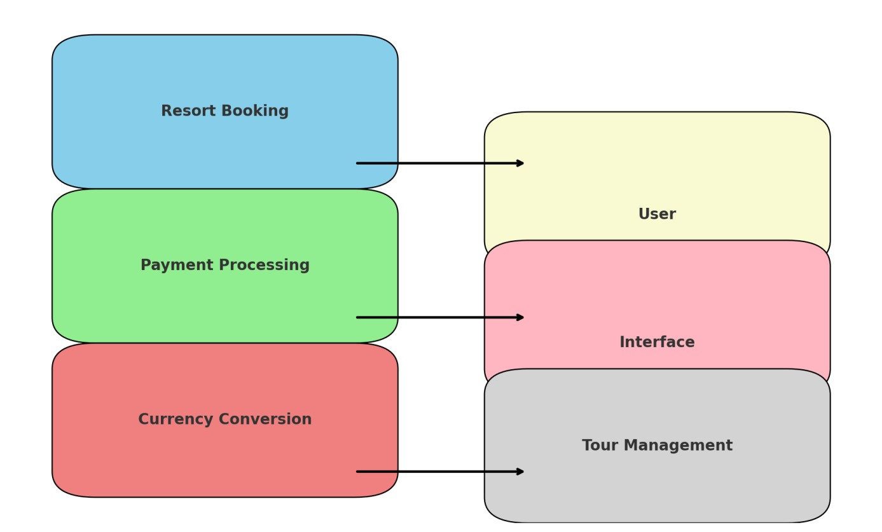

Figure 3.3 : Block diagram

## 3.4 FLOW CHART

Visit the website



Fill the pop up form

Accessing the

countries

boo

king

Date of travel

Choose the country

book

Stored in database

Confirm booking

Convert successfully

Currency convertor

Payment process

Registration form

Figure 3.4 Flow chart

## 3.5 PROCESS CYCLE

Front view

Currency convertor

Payment

Registration form

Database storage

Figure 3.5: Process diagram

**ACTIVITY DIAGRAM**

**3.6**

Visit the

website

boo

king

Fill the

form

Accessing

the country

Name, dob, travelling date,

number of people,

Dollar ,rupee ,pound etc..

Cash

holder name, c v v

number, pin number

Payment process

Currency

convertor

Registration form

Stored in

the

database

Figure 3.6: Activity diagram  **CHAPTER 4**

**MODULES**

### 4.1 MODULE DESCRIPTION

* Tour management module
* Resort booking module
* Tour management module
* Payment module
* Admin panel
* Currency convertor

# 4.1.1 USER MANAGEMENT MODULE

The User Management Module serves as the central hub for managing guest interactions and profiles in an integrated resort booking and tour management system. It provides essential features such as registration, login, access control, and a user dashboard with booking history, streamlining the user experience while enhancing operational efficiency.

* User Registration
* Login and Authentication
* Access Control
* User Dashboard
* Booking History

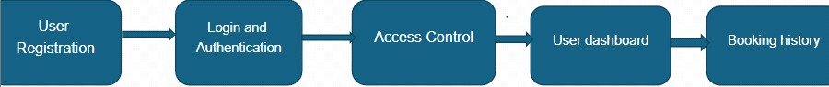

##### Figure 4.1 : User registration module

###### 4.1.1.1 User management module

The User Management Module in integrated resort booking and tour management systems is designed to provide a seamless and secure experience for guests while optimizing operational efficiency. It begins with a straightforward user registration process, allowing guests to sign up using personal details or third-party platforms like Google or Facebook, with options to customize preferences such as room types and activities. The login and authentication feature ensures secure access through multi-factor authentication (MFA), single sign-on (SSO), and session management for added safety. Access control uses role-based permissions, enabling guests to access only their profiles and bookings while allowing staff and admins to manage data and operations effectively. The user dashboard serves as a centralized hub where guests can view and manage bookings, check payment statuses, access loyalty points, and explore personalized offers. An integrated booking history feature maintains detailed records of past and current reservations, including payment summaries and downloadable e-receipts, with rebooking options for convenience. Additional features such as real-time notifications, multi-language support, and a built-in currency converter enhance usability, while integrated customer support tools ensure prompt assistance. This comprehensive module not only streamlines guest interactions but also empowers resorts to deliver tailored experiences, improve data security, and optimize workflows.

###### 4.1.1.2 Login and Authentication module

The Login and Authentication feature is designed to ensure secure and seamless access for all users while maintaining system integrity and data privacy. It begins with a user-friendly login process that supports multiple options, including email, username, or mobile number, allowing guests to choose their preferred method. For enhanced security, the system integrates multi-factor authentication (MFA), which requires users to verify their identity through an additional layer, such as an OTP sent via SMS or email, or authentication apps. This feature reduces the risk of unauthorized access while maintaining ease of use. Advanced capabilities like Single Sign-On (SSO) allow users to access multiple interconnected resort services—such as booking platforms, loyalty programs, or activity schedulers— using a single set of credentials, simplifying the experience for regular guests. The "Remember Me" option provides convenience by storing login information securely on trusted devices, enabling faster subsequent logins. Additionally, session management monitors active sessions and allows users to view and terminate unnecessary or unauthorized sessions remotely, enhancing account security. The login system is built with robust encryption protocols to protect sensitive user data during transmission and storage, ensuring compliance with data protection regulations. Overall, the Login and Authentication feature provides a balance of security and usability, offering peace of mind for users while safeguarding the resort’s digital ecosystem.

###### 4.1.1.3 Access control

The Access Control feature is a critical component of the system, designed to regulate user permissions and ensure that individuals have access only to the resources and information appropriate to their roles. This is achieved through a Role-Based Access Control (RBAC) framework that categorizes users into distinct groups such as guests, staff, and administrators, each with specific levels of access. For instance, guests are limited to their personal profiles and booking details, while staff members can manage reservations, assist guests, and handle transactions.

Administrators, on the other hand, are granted comprehensive access to oversee system operations, generate reports, and configure settings.

For added flexibility, custom permissions allow the creation of specialized roles, such as travel agents or corporate partners, enabling tailored access to specific features like group bookings or corporate discounts. The system also ensures data privacy by restricting visibility and interactions based on user roles, ensuring that sensitive information is accessible only to authorized personnel. Additionally, the module incorporates an audit trail, tracking all user activities to provide transparency and accountability, which is particularly useful for resolving disputes or monitoring misuse.

Access control features are integrated seamlessly into the platform, ensuring users encounter no unnecessary barriers while maintaining robust security measures. With these capabilities, the system balances functionality, security, and user convenience, providing a trustworthy environment for managing bookings and resort operations.

###### 4.1.1.4 User Dashboard

The User Dashboard serves as the central hub for managing and navigating all aspects of a guest's interaction with the resort's booking and tour management system. Upon logging in, users are greeted with a personalized overview that displays their account information, including name, membership status, and available loyalty points or rewards. The dashboard provides a comprehensive snapshot of current bookings, showcasing details such as accommodation types, check-in/check-out dates, and any scheduled activities, making it easy for guests to keep track of their upcoming plans.

Guests can also access a detailed booking history, which includes past stays, activities, and payment summaries, allowing them to quickly reference previous reservations, download invoices, or even repeat a booking with just a few clicks. The dashboard includes a section for payment management, displaying current balances, payment methods, and transaction statuses, enabling guests to make payments, review invoices, or modify payment preferences.

One of the key features of the dashboard is the integration of personalized offers and promotions, where users are presented with exclusive deals based on their booking history, preferences, or loyalty status. These offers can include discounts, upgrades, or access to special resort events. The intuitive design of the dashboard allows users to easily navigate between sections, modify bookings, or add additional services, ensuring a smooth, self-service experience. Additionally, the dashboard is responsive, ensuring that it functions seamlessly across devices, whether accessed from a desktop, tablet, or mobile phone.

The User Dashboard is not only a functional tool for managing reservations but also enhances the overall guest experience by providing easy access to all resort services, personalized recommendations, and relevant updates in one convenient location.

###### 4.1.1.5 Booking details

The Booking History feature is an essential part of the user experience, offering guests a detailed and organized record of all past, current, and upcoming reservations. This section allows guests to effortlessly review their entire booking journey, from initial reservations to final check-out. The feature displays key information such as reservation dates, room types, activities, and amenities booked during each stay, providing a clear and comprehensive view of past experiences.

For each booking, users can view payment summaries, including amounts paid, taxes, service fees, and the payment method used, ensuring transparency and helping guests track their spending. The system also allows for easy access to e-receipts and invoices, which can be downloaded, emailed, or printed for personal records or reimbursement purposes. This is particularly useful for business travelers or those needing expense documentation.

Guests can quickly filter and search through their booking history based on criteria such as date, booking type, resort location, or activity package, making it easy to locate specific stays or revisit preferred accommodations. Additionally, the rebooking option enables users to repeat a past reservation with a single click, saving time and effort, especially for guests who frequently visit or prefer certain accommodations or activities.

The Booking History section enhances the overall user experience by providing a comprehensive, organized record of past interactions with the resort, allowing guests to manage their preferences, keep track of payments, and easily plan future stays. This feature not only offers convenience and efficiency but also fosters guest loyalty by enabling easy access to repeat bookings and tailored recommendations based on their history.

## 4.2 RESORT BOOKING MODULE

The Resort Booking feature is designed to simplify the booking process for guests while providing them with all the necessary tools to choose and secure their stay at the resort. It begins with an intuitive search functionality that allows users to filter and search based on various criteria such as location, room type, amenities, price range, and availability. Guests can also specify their preferred check-in and check-out dates to view only the available rooms. This flexibility ensures that users can find the ideal resort and accommodations that meet their specific needs.

Once a resort is selected, the system provides comprehensive room details including images, descriptions, bed configurations, and additional features such as views, amenities, and proximity to key areas of the resort. This helps guests make informed decisions when choosing their accommodations. Users can also view the number of rooms available for the selected dates, allowing them to adjust their booking if they need multiple rooms or prefer specific room types.

The booking process is straightforward and allows guests to select the number of rooms they wish to book, along with any additional services or packages, such as dining, spa treatments, or guided tours. The system provides a real-time booking calendar to display availability, so guests can easily see which dates are open. Once the guest has selected their room and services, they can proceed to the payment page, where various payment options such as credit cards, digital wallets, and bank transfers are available for secure transactions.

After completing the payment, guests receive a booking confirmation, including all the reservation details, and can access it through their user dashboard or via email/SMS. The system also allows guests to modify or cancel their bookings through their dashboard if their plans change. This feature is designed to provide a seamless, user-friendly booking experience, ensuring that guests can find, select, and reserve their resort accommodations with ease and confidence.

* Search Functionality
* Room Details and Image Facilities
* Room Selection and Number of Rooms
* Booking Process
* Payment Process
* Confirmation and Reservation Details
* Booking Management



managem

ent



Waivers

and offers



Room

selection



Booking

process



Room

images



Confirm &

reserve



Payment

process

**searching**

#### Figure 4.2 : Resort booking module

##### 4.2.1 Search functionality

The search functionality is a vital feature in the resort booking system, enabling guests to find accommodations that best suit their needs quickly and efficiently. When a user begins their search, they are presented with multiple filters, such as location, room type, price range, amenities, and availability. These filters allow users to narrow down their options, helping them find exactly what they are looking for. For example, if a guest is looking for a resort with a spa in a specific location, they can set the filters to display only those resorts that meet those criteria. The feature also allows users to input specific check-in and check-out dates, ensuring that only available rooms for their selected dates are shown. By combining location, room preferences, amenities, and budget filters, the search functionality ensures guests find the most relevant resorts without wasting time sifting through irrelevant results.

##### 4.2.2. Room Details and Images

Once guests have identified a resort of interest, the room details feature provides comprehensive information about each room available for booking. Each room listing includes a detailed description that covers essential aspects such as the room type (e.g., standard, deluxe, suite), the size of the room, bed configurations, and specific amenities offered (such as Wi-Fi, air conditioning, or mini-bars). In addition to these descriptions, high-quality images of the rooms, along with photos of the resort’s facilities and surroundings, are provided. These images give guests a realistic view of what to expect, ensuring that the room’s aesthetic and amenities align with their expectations. For example, if a guest is looking for a room with a balcony overlooking the ocean, the images will highlight that feature. This feature is crucial for guests who want to visualize their accommodations before making a final decision.

##### 4.2.3. Number of Rooms Available

The number of rooms available feature is critical for guests who need to secure multiple rooms or ensure they have enough space for their group or family. When booking, guests can check how many rooms are available for the selected dates. This feature helps prevent overbooking, as users can see in real-time if rooms are available for their desired check-in and check-out dates. It also ensures transparency, allowing guests to make an informed decision about how many rooms to reserve. For instance, if a family needs three rooms for a multi-generational trip, they can immediately see if enough rooms are available at their chosen resort. This feature is also helpful during peak seasons when resorts may have limited availability, providing guests with the information they need to adjust their booking or select alternate dates.

##### 4.2.4 Booking Process

The booking process is designed to be user-friendly, guiding guests step-by-step through the reservation process. After choosing the room(s) and confirming their number, guests are presented with a booking summary that includes the selected room(s), dates of stay, the total cost, and any additional services or amenities they may have added (e.g., airport transfers, spa treatments, or tours). The summary gives guests an opportunity to review their choices before proceeding to payment. A realtime availability calendar is integrated into the system, allowing guests to check if the selected room(s) are still available for the dates they have chosen. This calendar updates in real-time to prevent double-booking, ensuring that only available rooms are shown. The clear breakdown of the booking, including the cost and services, provides transparency, making guests feel confident that their booking choices are accurate before payment.

##### 4.2.5 Payment Process

The payment process is an integral part of the resort booking system, designed for convenience, security, and flexibility. After reviewing the booking details, guests are prompted to enter payment information. The system offers multiple payment options such as credit cards, debit cards, digital wallets (e.g., PayPal, Google Pay), or bank transfers, allowing guests to choose their preferred method. The system uses a secure payment gateway that encrypts payment information, ensuring that all transactions are safe and secure. Guests can also see a detailed cost breakdown that lists the room price, taxes, service fees, and any additional charges for services they have selected. This transparency ensures that there are no hidden charges, providing a hassle-free experience for users. By offering various payment methods and guaranteeing secure transactions, the payment feature makes the booking process as smooth and accessible as possible.

##### 4.2.6 Booking Confirmation

Once the payment is processed, guests receive an instant booking confirmation. This confirmation serves as proof of reservation and includes all the relevant details about the booking, such as reservation number, check-in/check-out dates, room type, and the total cost. Additionally, a summary of any added services, such as excursions or dining packages, is included. The booking confirmation is sent directly to the guest via email or SMS, providing immediate proof of their reservation. For added convenience, the guest’s user dashboard also stores a digital copy of the booking, which can be accessed at any time for reference. This instant confirmation gives guests peace of mind that their booking has been secured and serves as a point of reference for any future inquiries or modifications.

##### 4.2.7 Booking Management

The booking management feature allows guests to easily view, modify, or cancel their reservations. After logging into their user account, guests can access their booking details from their user dashboard. If a guest’s plans change, they can update their reservation to reflect new check-in/check-out dates, select a different room type, or even add extra services such as additional nights or room upgrades. In case of cancellation, the system allows users to cancel their reservation based on the resort’s cancellation policy. The system will often provide a refund if the booking is canceled within a specific time frame. Additionally, real-time updates are sent to the guest regarding any changes to their booking or the resort’s availability, keeping the guest informed at all times. This feature enhances flexibility and gives guests the ability to adjust their plans without hassle.

##### 4.2.8 Loyalty Programs and Offers

The loyalty programs and offers feature is designed to reward guests for repeat bookings and foster customer loyalty. Guests can earn loyalty points each time they book, which can later be redeemed for discounts, room upgrades, or exclusive offers like free meals or activities. This rewards returning guests, encouraging them to choose the same resort for future stays. Additionally, guests may be offered personalized discounts or special packages based on their booking history, loyalty status, or the resort’s ongoing promotions. For instance, guests who frequently book for family vacations may be offered a discounted family package or a free child’s meal during their stay. The loyalty program not only benefits frequent guests by providing tangible rewards but also helps resorts increase repeat business and enhance guest satisfaction by offering personalized incentives.

## 4.3 TOUR MANAGEMENT MODULE

The Tour Management Module is a comprehensive feature within a resort or travel platform designed to help users find, customize, book, and confirm their tours effortlessly. This module offers a streamlined experience for both individual travelers and group bookings, providing a clear, efficient way to organize and manage tour bookings from start to finish. Here’s an elaboration of the key features within the Tour Management Module,

* View
* Customize
* Book
* Confirm

•

view

book

customize

confirm

#### Figure 4.3 : Tour management module

##### 4.3.1 View

The View feature allows users to browse and explore various tours that are available. This function typically presents a list of tours, which users can filter based on their preferences, such as destination, price range, duration, or type of experience (e.g., cultural, adventure, or luxury). When a user selects a specific tour, they are provided with a detailed overview, including the tour itinerary, destinations covered, and activities included. Additionally, users can view highquality images, video previews, and customer reviews of the tour, helping them to visualize the experience and gain insights from past travelers. The View feature gives users all the necessary information to make an informed decision before they proceed to booking.

##### 4.3.2 Customize

The Customize feature allows users to tailor their tour experience according to personal preferences or specific needs. After selecting a tour, guests can adjust elements of the itinerary, such as adding extra activities (e.g., an extra sightseeing tour or a special event), upgrading accommodations, or choosing special transportation options, like private vehicles. This feature is particularly beneficial for group bookings or special events, allowing for the customization of the tour to accommodate large groups, family needs, or corporate requirements. Furthermore, users can add specific dietary requests, accessibility needs, or additional services like a private tour guide or VIP experiences. The Customize option ensures that users can adapt the tour to their unique requirements, ensuring a highly personalized and enjoyable experience.

##### 4.3.3 Book

The Book feature facilitates the reservation of the selected tour after users have reviewed and customized their preferences. Upon choosing the desired tour and confirming the availability for the travel dates, users are prompted to provide necessary details such as the number of travelers, personal information, and any special requirements. The system will then display the final price, which includes the cost of the tour, along with any additional charges for optional services or upgrades selected during the customization process. Users can proceed with secure payment options, which typically include credit/debit cards, bank transfers, or digital wallets. Once the payment is processed successfully, users receive an immediate confirmation that the tour has been reserved, marking the completion of the booking process.

##### 4.3.4 Confirm

The Confirm feature provides users with confirmation of their booking, ensuring that all the details of the reservation are accurate and finalized. Once a user has completed their booking, the system sends an instant confirmation email and provides a digital confirmation on their account or dashboard. This confirmation includes essential information such as the tour reference number, tour dates, tour itinerary, pricing breakdown, and any additional services or customizations selected during the booking. For convenience, a QR code or unique booking reference may be included, which can be presented to the tour provider on the day of the tour for verification. Additionally, the confirmation email may include further details, such as packing lists, travel tips, and contact information for the tour guide or operator, ensuring the user is well-prepared and informed for the tour. The Confirm feature helps guests feel assured that their booking is secure, and provides them with all the necessary information for a smooth and enjoyable tour experience.

## 4.4 PAYMENT MODULE

The Payment Module is a critical component of any booking or transaction system, ensuring that users can securely complete their purchases for tours, resort bookings, or other services. The module provides an easy, efficient, and secure process for users to make payments online. Below is a detailed explanation of the key features within the Payment Module:

* Select and Enter
* Verify and Confirm
* Process and Validate • Notify and Generate.

Select

and enter

Process

and

validate

Notify

and

generate

Verify and

confirm

#### Figure 4.4 : Payment module

##### 4.4.1. Select and Enter

The Select and Enter feature is the first step in the payment process. It allows users to select their payment method and enter the necessary payment details. After the user has completed selecting a tour or booking service, the system presents the payment page. Here, the user can choose from a variety of payment options, such as credit/debit cards, digital wallets (e.g., PayPal, Google Pay), bank transfers, or other supported payment methods. After selecting their preferred method, the user enters the required payment information. This may include card details like card number, expiration date, and CVV, or login credentials for digital wallets. For bank transfers, the system may prompt the user to input bank account details. This step ensures that all the required payment details are collected for the next stage of the transaction.

##### 4.4.2 Verify and Confirm

Once the user has entered their payment details, the Verify and Confirm feature ensures the accuracy and validity of the provided information. This process includes verifying the correctness of the entered payment details, such as checking the format of the credit card number or ensuring that the billing address matches the details registered with the payment provider. The system may also perform a security check, such as a two-factor authentication or 3D Secure verification, where the user may be required to confirm the transaction through a code sent via SMS or email. This step is essential for reducing the chances of fraudulent transactions and confirming that the user is the legitimate cardholder or account holder. After successful verification, the user is presented with a summary of the transaction, including the total amount, payment method, and booking details. The user then confirms that the information is correct and proceeds to the next stage.

##### 4.2.3 Process and Validate

The Process and Validate feature is the core of the payment module. Once the user confirms their payment details, the system communicates with the payment gateway to process the transaction. The gateway performs authorization checks to validate the payment method and ensure that the user has sufficient funds or credit. If the payment is through a credit card, the system checks with the card issuer to ensure that the card is active and the transaction is authorized. The system also checks whether the entered payment details are correct and whether the transaction complies with any security measures in place. If the payment passes the validation checks, the system proceeds to process the payment, transferring the specified amount from the user’s account to the merchant’s account. If there are any issues, such as insufficient funds or invalid card details, the user will be notified and given the chance to correct the problem or select a different payment method.

##### 4.4.4 Notify and Generate

The final step in the payment process is the Notify and Generate feature. After the transaction is successfully processed, the system sends a confirmation notification to the user. This notification typically includes a payment receipt, transaction ID, and a breakdown of the payment, such as the total amount, service fees, and any discounts applied. The system may also send a confirmation email containing all these details and the booking confirmation for the reserved tour, resort, or service. For added convenience, the system may also generate a digital invoice or receipt that the user can download and keep for their records. In case the payment is unsuccessful, the system notifies the user of the error, providing an explanation (e.g., insufficient funds, incorrect payment details) and prompting them to try again with an alternative method. This step ensures that users are kept fully informed about the status of their payment and that the system is transparent about the transaction details.

### 4.5 ADMIN PANEL

The Admin Panel Module is designed to provide administrators with the tools needed to manage and oversee the system effectively. It allows administrators to monitor the entire platform, configure settings, generate reports, respond to customer queries, and maintain the overall system. Below is a detailed explanation of the key features within the Admin Panel Module.

* Monitor and Configure
* Generate and Review
* Response • Maintain.

Monitor

and

configure

Generate

and

review

response

maintain

#### Figure 4.5 : Admin panel module

##### 4.5.1 Monitor and Configure

The Monitor and Configure feature allows administrators to keep track of the platform’s overall health and performance while configuring system settings according to the needs of the business. Through this feature, administrators can monitor user activity, such as bookings, payments, and user interactions, and track how the platform is being used. The system provides real-time analytics and performance metrics, which helps administrators identify any potential issues or areas for improvement. Administrators can also configure system settings such as payment gateway integration, tour or resort options, user roles, and access levels. This feature enables them to adjust platform settings quickly, ensuring that the system remains optimized and user-friendly. It helps ensure the seamless running of the platform and allows for customizations that align with business needs.

##### 4.5.2 Generate and Review

The Generate and Review feature allows administrators to generate important reports and review data related to various aspects of the business. These reports might include sales data, user activity logs, booking trends, revenue analysis, and customer feedback. The ability to generate reports allows administrators to track performance over time, assess business growth, and identify areas for improvement. The review aspect refers to the administrator's ability to assess the generated data, spot patterns, and make data-driven decisions. For example, an administrator may use this feature to review booking patterns, adjust pricing strategies, or identify which tours or resorts are most popular. The Generate and Review feature is crucial for making informed decisions and ensuring that the platform operates efficiently.

##### 4.5.3 Response

The Response feature focuses on handling communication with users, ensuring that any customer queries, complaints, or feedback are addressed promptly. Through this feature, administrators can respond to customer inquiries, such as requests for information, booking issues, payment concerns, or tour-specific queries. The platform may integrate customer support tickets, allowing users to submit their questions or issues, and administrators can view, track, and respond to these tickets. Additionally, this feature can include managing reviews and ratings from users, ensuring that customer feedback is acknowledged and addressed. The Response feature helps maintain a high level of customer satisfaction, offering quick and effective communication between the platform administrators and users.

##### 4.5.4 Maintain

The Maintain feature allows administrators to ensure that the system remains in good working condition by performing regular maintenance tasks. These tasks may include software updates, bug fixes, data backups, and security checks. The system might also have tools to maintain the database, such as removing outdated information, optimizing performance, and ensuring the accuracy of user data and transaction logs. Administrators can also use the Maintain feature to manage content updates, like adding or updating tour packages, resort listings, and pricing changes. Regular maintenance is essential for preventing system failures, keeping the platform secure, and ensuring that users have a smooth experience. This feature helps keep the platform running efficiently and up to date with the latest features and security measures.

### 4.6 Currency converter module

A currency converter is an essential feature in an integrated resort booking and tour management system, particularly for catering to a global audience. It allows users to view prices, make payments, and compare costs in their preferred currency, ensuring transparency and convenience during the booking process. This functionality not only improves the user experience but also eliminates the confusion associated with exchange rates and foreign transactions.

The currency converter operates by integrating real-time exchange rate APIs, such as those provided by Open Exchange Rates or CurrencyLayer, into the system. This ensures that users receive accurate and up-to-date conversion values when browsing or finalizing their bookings. For instance, a customer booking a resort from Europe can view the pricing in euros, while another user from the United States can see the equivalent amount in dollars.

Additionally, the system can provide automatic currency detection based on the user's location or allow them to manually select their preferred currency. During the payment process, the currency converter ensures that the transaction is processed correctly in the user's selected currency while updating the booking system in the resort's base currency.

The inclusion of a currency converter also enhances the system's appeal to international travelers, allowing the business to attract a broader audience.

**CHAPTER 5**

**SYSTEM SPECIFICATION**

### 5.1 SOFTWARE REQUIREMENTS

* WINDOWS
* VISUAL STUDIO CODE
* HTML/CSS
* SQLITE
* PYTHON

### 5.2 HARDWARE REQUIREMENTS

* PROCESSOR - MINIMUM INTEL I5
* RAM - [8GB]
* CLOUD STORAGE **/** HIGH SPEED INTERNET

#### 5.1.1 WINDOWS

Windows has made significant contributions to the development and functionality of integrated resort booking and tour management systems, providing a robust platform for both administrators and users. As an operating system, Windows supports the seamless operation of essential software, offering compatibility with a wide range of tools required for booking and management processes. Its user-friendly interface simplifies the interaction for administrators managing bookings, tours, and customer data, while also enhancing the end-user experience with intuitive applications. Windows servers play a pivotal role in hosting booking systems, ensuring reliability, scalability, and security for online transactions and customer information. The integration of features like multitasking, cloud synchronization through platforms like Microsoft Azure, and compatibility with enterprise-grade database systems ensures that resort and tour management platforms can operate efficiently. Additionally, the availability of Microsoft Office tools aids in reporting, data analysis, and communication, supporting better decisionmaking and customer service. With its vast ecosystem of applications and a focus on system security and performance, Windows remains a cornerstone for the digital infrastructure behind modern integrated resort booking and tour management systems.

#### 5.1.2 VISUAL STUDIO CODE

Visual Studio Code (VS Code) plays a vital role in the development of integrated resort booking and tour management systems, offering developers a powerful, flexible, and efficient platform for coding and debugging. As a lightweight yet robust code editor, VS Code supports multiple programming languages and frameworks commonly used in building such systems, including JavaScript, Python, C#, and PHP. Its extensive library of extensions enhances development capabilities, providing tools for database management, API testing, and front-end design, which are crucial for creating user-friendly interfaces and ensuring seamless backend operations. Features like IntelliSense, real-time debugging, and integrated Git support streamline the coding and version control processes, allowing development teams to collaborate effectively and maintain highquality code. Additionally, VS Code's support for cloud-based development environments, such as those on Microsoft Azure, facilitates scalability and integration with cloud-hosted booking systems. By simplifying complex development tasks and enhancing productivity, Visual Studio Code significantly contributes to the creation of efficient, secure, and scalable solutions for resort booking and tour management.

#### 5.1.3 APACHE

Apache HTTP Server (commonly known as Apache) significantly contributes to the infrastructure of integrated resort booking and tour management systems by serving as a reliable and scalable web server. As an opensource solution, Apache provides a flexible platform for hosting websites and web applications, enabling seamless access to booking portals and tour management interfaces. It supports multiple programming languages and frameworks, such as PHP, Python, and Java, allowing developers to build dynamic and responsive systems tailored to user needs. Apache’s modular architecture ensures that specific functionalities, like SSL for secure transactions or URL rewriting for improved navigation, can be easily added or customized. Its robust performance capabilities ensure high availability and efficient handling of large volumes of traffic, a critical requirement for systems catering to global users. Additionally, Apache integrates smoothly with other tools like MySQL databases and content management systems, providing a cohesive ecosystem for managing resort and tour operations. With its security features, including support for firewalls and authentication protocols, Apache ensures the protection of sensitive customer and transaction data, making it a cornerstone for reliable and secure integrated resort booking and tour management platforms.

**CHAPTER 6**

### METHODOLOGY

Implementing an integrated resort booking and tour management system involves a comprehensive approach that combines multiple methodologies to ensure the platform is efficient, user-friendly, scalable, and secure. The process begins with requirements analysis, where stakeholder needs are identified through interviews, surveys, and workshops. This stage helps define the system’s scope, such as key features for resort search, tour customization, booking, and payment processing. User personas and use cases are created to understand how customers, administrators, and other users will interact with the system, laying the foundation for a welltargeted solution.

The development phase typically follows the Agile methodology, enabling iterative and incremental progress. Agile facilitates continuous feedback from stakeholders, ensuring that the system evolves in alignment with business needs. By dividing the project into sprints or phases, developers can focus on specific modules, such as user management, booking systems, or payment integration. An initial Minimum Viable Product (MVP) is delivered, followed by successive iterations to add features and enhancements. Regular scrums and review sessions help maintain transparency and address challenges promptly.

System design is another critical phase, emphasizing modularity and scalability. A robust architecture is developed, where each component—like the user management module, booking interface, and analytics engine—functions as an independent yet integrated unit. Detailed database schemas are created to manage critical data, including user profiles, booking histories, and payment transactions. Prototypes and wireframes are designed to visualize the user interface, ensuring an intuitive experience for customers and administrators alike. This phase also considers integration with external services, such as third-party APIs for payment gateways, currency converters, and communication tools like email or SMS notifications.

The development and integration phase involves writing the codebase using modern programming languages and frameworks, such as Python, JavaScript (React or Angular), or PHP. Developers ensure seamless communication between the system’s frontend and backend, often using RESTful APIs or GraphQL. Integration of cloud-hosted services, like AWS or Azure, provides scalability and redundancy, ensuring the system can handle high volumes of concurrent users. Additionally, automated workflows, such as real-time booking confirmations and invoicing, enhance operational efficiency.

Once the system is built, testing and quality assurance become crucial. Rigorous testing ensures that the system performs as expected under various conditions. Unit testing validates individual components, while integration testing ensures that all modules work together seamlessly. Load testing simulates peak traffic scenarios to measure the system’s responsiveness and scalability. Security testing identifies and addresses vulnerabilities, ensuring the protection of sensitive data such as customer information and payment details.

Deployment methodology involves releasing the system for public or internal use, often leveraging DevOps practices to automate deployment pipelines. The system is hosted on scalable platforms, such as cloud servers, and configured for data backups and disaster recovery. Deployment also includes setting up monitoring tools to track system performance and user interactions in real time.

To ensure user adoption, training and documentation play a pivotal role. Comprehensive manuals, video tutorials, and FAQs are created for customers, while staff and administrators are trained through workshops or live demonstrations. A dedicated customer support system, such as chatbots or helplines, ensures real-time assistance for users encountering issues.

Post-launch, maintenance and continuous improvement ensure the system remains updated and responsive to evolving needs. Regular updates introduce new features, enhance security, and optimize performance. User feedback is collected through surveys and analytics tools to identify pain points and prioritize improvements. Additionally, periodic audits and monitoring of system logs help administrators address potential issues before they impact users.

Another critical aspect is data analytics and reporting, which provides actionable insights into user behavior and system performance. Analytics tools track metrics like booking trends, popular tour packages, and revenue data, enabling businesses to make informed decisions. Customized reports provide stakeholders with a clear picture of operational efficiency and customer preferences, allowing for strategic adjustments to offerings and marketing efforts.

Finally, compliance and legal methodology ensures that the system adheres to relevant regulations. For instance, compliance with data protection laws like GDPR ensures user privacy, while adherence to PCI-DSS standards safeguards payment processes. Clear terms and conditions, refund policies, and disclaimers are incorporated into the system to protect both the business and its customers.

In summary, the implementation of an integrated resort booking and tour management system requires a methodical approach that addresses technical, operational, and regulatory aspects. By following these methodologies, businesses can deliver a seamless and secure platform that enhances user satisfaction while driving operational efficiency and business growth.

* Requirements Analysis
* Agile Development Methodology
* System Design Development and Integration
* Development and Integration
* Testing and Quality Assurance
* Deployment Methodology
* User Training and Documentation
* Maintenance and Continuous Improvement
* Data Analytics and Reporting
* Compliance and Legal Methodology

### 6.1 KEY FEATURES OF METHODOLOGY

#### 6.1.1 Requirements Analysis

The first step in implementing a resort booking and tour management system is requirements analysis. This involves gathering and documenting the needs of various stakeholders, including customers, resort operators, and tour managers. By conducting interviews, surveys, and workshops, the team identifies the essential features and functionalities of the system. These may include resort searches, booking and payment processes, and tour customization options. Use cases and user personas are developed to better understand the interactions users will have with the system. This step ensures that the project scope is clearly defined and aligned with business objectives, creating a solid foundation for development.

#### 6.1.2 Agile Development Methodology

The Agile methodology is commonly used to build resort booking and tour management systems because of its iterative and flexible approach. The project is divided into smaller sprints or cycles, each focusing on delivering specific features or modules. Regular meetings, or scrums, are held to track progress and resolve any challenges. By delivering a Minimum Viable Product (MVP) early in the process, stakeholders can provide feedback that shapes subsequent iterations. Agile ensures continuous improvement, quicker delivery of features, and better alignment between the system’s functionality and user expectations.

#### 6.1.3 System Design

System design focuses on creating a robust and scalable architecture to support the platform’s requirements. This includes designing modular components such as user management, booking modules, and analytics systems. Detailed database schemas are developed to store and retrieve information like user profiles, booking histories, and payment transactions efficiently. Wireframes and prototypes are created to plan user-friendly interfaces, ensuring a seamless experience for customers and administrators. The design phase also incorporates planning for integrations with third-party services such as payment gateways and currency converters to ensure a cohesive and efficient system.

#### 6.1.4 Development and Integration

In this phase, the actual system is built using modern programming languages and frameworks. Developers work on frontend and backend components, ensuring smooth interactions between the user interface and the system’s core functionalities. APIs are implemented to enable communication between different modules and external services, such as payment processors and notification systems. The system is hosted on scalable platforms, such as cloud-based servers, to ensure it can handle large volumes of traffic. This phase also includes the automation of key workflows, such as booking confirmations and customer notifications, to enhance operational efficiency.

#### 6.1.5 Testing and Quality Assurance

Testing and quality assurance are critical to ensuring the system functions as intended. Unit testing validates individual components, while integration testing ensures that all modules work together seamlessly. Load testing simulates peak usage scenarios to measure the system’s responsiveness under heavy traffic. Security testing is conducted to identify vulnerabilities and safeguard sensitive data, such as customer information and payment details. This comprehensive testing process ensures that the system is reliable, secure, and capable of delivering a smooth user experience.

#### 6.1.6 Deployment Methodology

Once the system has passed all tests, it is deployed for public or internal use. Using DevOps practices, the deployment process is automated to ensure smooth and errorfree implementation. The system is hosted on scalable and secure platforms, such as AWS or Azure, to handle user demands. Backup and disaster recovery mechanisms are configured to protect data and ensure service continuity. Monitoring tools are set up to track system performance and user interactions in real time, allowing administrators to identify and resolve issues quickly.

#### 6.1.7 Maintenance and Continuous Improvement

After deployment, the system enters a maintenance phase to ensure its ongoing performance and relevance. Regular updates are rolled out to address user feedback, fix bugs, and introduce new features. Performance monitoring tools are used to identify bottlenecks and optimize system operations. Security updates are applied regularly to protect against evolving threats. Continuous improvement is guided by customer insights and usage data, allowing the system to adapt to changing business needs and user expectations over time.

#### 6.1.8 Data Analytics and Reporting

Data analytics plays a vital role in enhancing decision-making and optimizing the system’s performance. Analytics tools monitor key metrics, such as booking trends, user behavior, and revenue patterns. The insights gained are used to refine offerings, target marketing efforts, and improve customer satisfaction. Reporting tools generate detailed summaries for stakeholders, providing a clear view of operational efficiency and business performance. This data-driven approach ensures that the system continues to deliver value to both users and administrators.

#### 6.1.9 Compliance and Legal Methodology

Compliance with legal and regulatory standards is essential for the credibility and security of the system. The system is designed to adhere to data protection laws, such as GDPR, ensuring that user data is handled responsibly. Payment processes comply with PCI-DSS standards to protect financial transactions. The platform includes clear terms and conditions, refund policies, and disclaimers to establish transparency and trust with users. By prioritizing compliance, the system safeguards its users and maintains its reputation in the market.

**CHAPTER 7**

**CONCLUSION AND FUTURE ENHANCEMENT**

### 7.1 CONCLUSION

The integrated resort booking and tour management system provides a comprehensive platform for streamlining the processes of searching, booking, managing tours, and ensuring a seamless user experience. With its modular design, secure payment systems, and user-friendly interfaces, the system addresses the needs of travelers, administrators, and resort operators alike. By leveraging robust technologies and scalable infrastructure, the platform ensures high performance, reliability, and security. From initial user registration to tour confirmations, every step is designed to enhance efficiency and customer satisfaction. This system not only simplifies operations but also sets the stage for innovation in the hospitality and tourism industries.

### 7.2 FUTURE ENCHANCEMENT

To further improve the system’s capabilities and user experience, several advanced features can be integrated in future updates:

**Language Translator**: A built-in language translation feature will cater to a diverse user base, enabling customers to access the platform in their preferred language. This functionality will make the system more inclusive, allowing seamless communication and reducing language barriers for international travelers.

**Voice Assistant**: Integrating voice assistant technology will provide hands-free navigation and interaction for users. Customers will be able to search for resorts, customize tours, and complete bookings using voice commands, enhancing convenience and accessibility, especially for users with disabilities.

**Trip Cancellation and Refund Management**: Adding a dedicated module for trip cancellations and refunds will allow users to cancel bookings easily and receive automated updates on refund processes. This feature will provide greater flexibility and transparency, improving customer trust and satisfaction.

By implementing these future enhancements, the integrated resort booking and tour management system will continue to evolve, meeting the ever-changing needs of the travel and tourism industry while providing users with a more personalized, intuitive, and accessible experience.

**APPENDIX – 1**

**SOURCE CODE**

### App.py

|  |
| --- |
| def init_db():  conn = sqlite3.connect('heeniya_voyage.db') cursor = conn.cursor()    # Create bookings table if not exists  cursor.execute('''CREATE TABLE IF NOT EXISTS bookings ( id INTEGER PRIMARY KEY AUTOINCREMENT, name TEXT, age INTEGER, dob TEXT, mobile TEXT, persons INTEGER, travel_date TEXT, days INTEGER  )''')    # Create payments table to store payment details cursor.execute('''CREATE TABLE IF NOT EXISTS payments ( id INTEGER PRIMARY KEY AUTOINCREMENT, cardholder TEXT, card_number TEXT, expiry TEXT, cvv TEXT  )''')    conn.commit() conn.close()      # Routes |

|  |
| --- |
| @app.route('/') def home():  return render_template('tour_management.html')    @app.route('/book') def book():  return render_template('book.html')    @app.route('/payment', methods=['POST']) def payment():  # Save booking details in DB data = request.form  conn = sqlite3.connect('heeniya_voyage.db') cursor = conn.cursor()  cursor.execute('''INSERT INTO bookings (name, age, dob, mobile, persons, travel_date, days)  VALUES (?, ?, ?, ?, ?, ?, ?)''',  (data['name'], data['age'], data['dob'], data['mobile'], data['persons'], data['date'], data['days'])) conn.commit() conn.close()  return render_template('payment.html', amount=1500 * int(data['persons'])) # Example calculation    @app.route('/currency-converter', methods=['GET', 'POST']) # Updated the route to use hyphens def currency_converter(): if request.method == 'POST':  try:  # Get form data  amount = float(request.form.get('amount')) from_currency = request.form.get('from_currency') to_currency = request.form.get('to_currency')  # Fetch conversion rates |

|  |
| --- |
| response = requests.get(f"{API_URL}{from_currency}") if response.status_code == 200:  rates = response.json().get('rates', {}) if to_currency in rates:  converted_amount = amount * rates[to_currency] return render_template( 'currency_converter.html',  converted_amount=round(converted_amount, 2), from_currency=from_currency, to_currency=to_currency, amount=amount  ) else:  error = f"Currency {to_currency} not supported." else:  error = "Failed to fetch conversion rates. Please try again later." except ValueError:  error = "Invalid amount entered. Please enter a numeric value."  # Handle errors and return to the form  return render_template('currency_converter.html', error=error)  # Render the converter form initially  return render_template('currency_converter.html', converted_amount=None)  @app.route('/confirm-payment', methods=['POST']) def confirm_payment(): # Get form data  cardholder = request.form.get('cardholder') card_number = request.form.get('card') expiry = request.form.get('expiry') cvv = request.form.get('cvv') |
| # Store payment details in DB  conn = sqlite3.connect('heeniya_voyage.db') cursor = conn.cursor()  cursor.execute('''INSERT INTO payments (cardholder, card_number, expiry, cvv)  VALUES (?, ?, ?, ?)''',  (cardholder, card_number, expiry, cvv)) conn.commit() conn.close()    return render_template('tour_management.html')    if __name__ == '__main__':  init_db() app.run(debug=True) |

Figure 2.1 Source code of program

**APPENDIX-2**

**SCREENSHOTS**

### SAMPLE OUTPUT

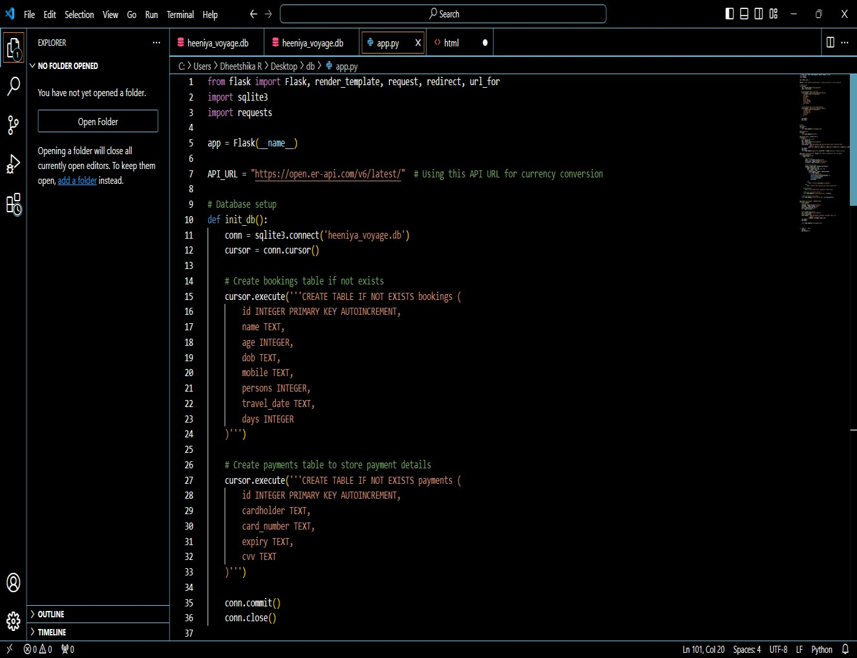

### Figure 2.2 : Execution of code

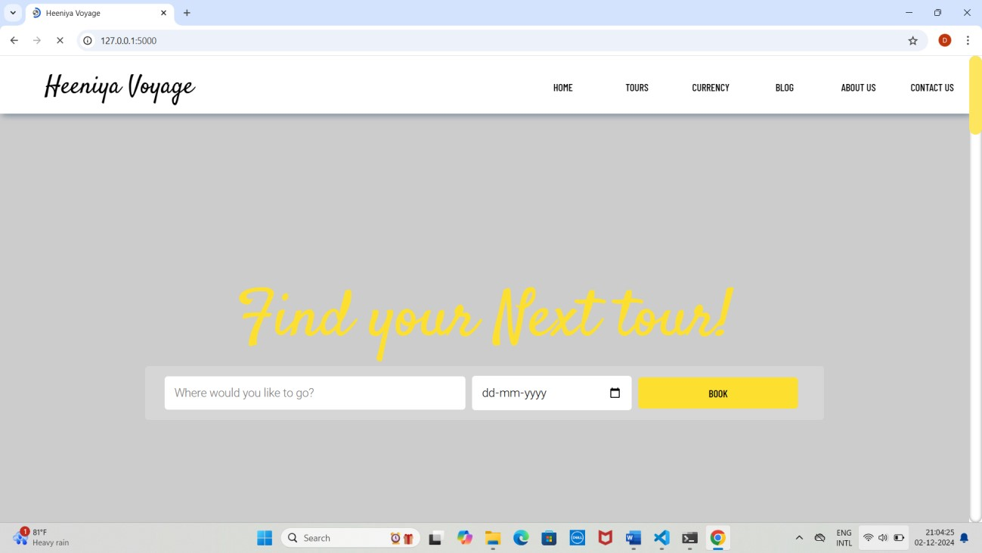

### Figure 2.3 :Front page of website

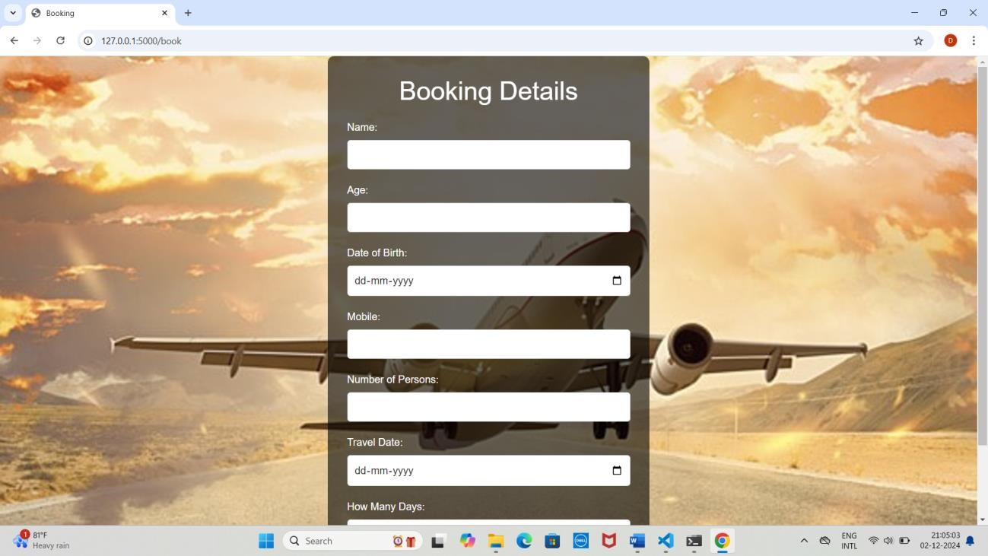

#### Figure 2.4 : Registration form

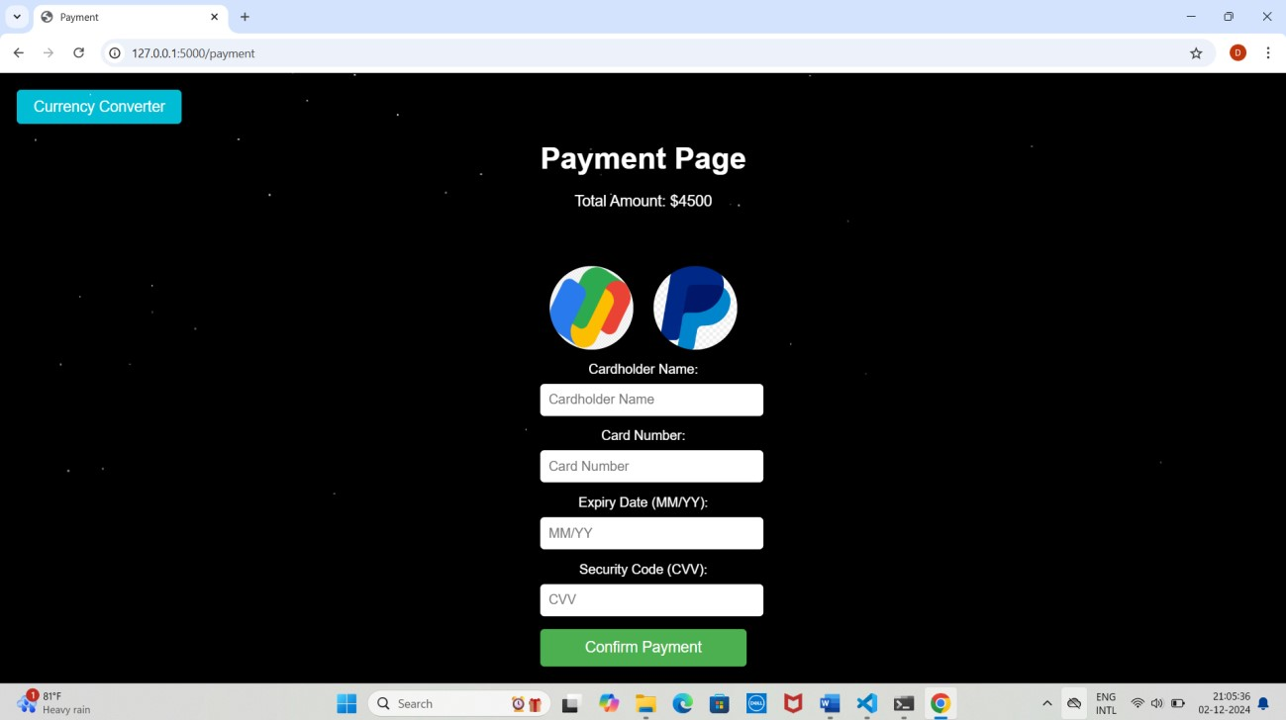

#### Figure 2.5 : Payment process

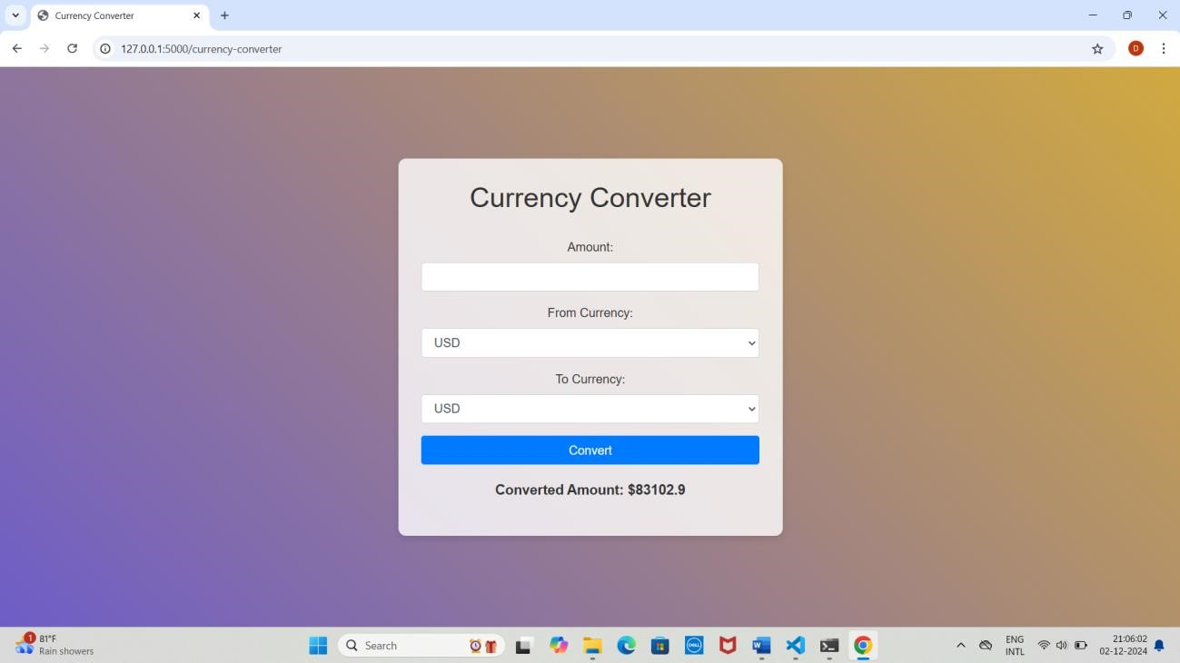

Figure 2.6: Currency convertor

### REFERENCES

1. Smith, J., & Brown, K. (2020). Modern Tourism Systems: Innovations in Hospitality and Travel Management. Tourism Press.
2. Patel, R. (2018). Software Architecture for Scalable Systems. TechWorld Publications.
3. Johnson, L. (2019). "Advances in Online Booking Platforms and Their Impact on the Hospitality Industry." Journal of Tourism and Hospitality Technology, 12(3), 245-263.
4. Microsoft Azure. "Scalable Cloud Solutions for Hospitality." Retrieved from [https://azure.microsoft.com.](https://azure.microsoft.com/)
5. AWS. "Building Scalable Applications for Travel and Tourism." Retrieved from [https://aws.amazon.com.](https://aws.amazon.com/)
6. PayPal Developer. "Integrating Secure Payment Gateways." Retrieved from [https://developer.paypal.com.](https://developer.paypal.com/)
7. Statista (2023). "Global Online Travel Booking Statistics and Trends."
8. World Tourism Organization (UNWTO). "Digital Transformation in the Tourism Industry."
9. General Data Protection Regulation (GDPR). European Union.PCI DSS. "Payment Card Industry Data Security Standard."
10. Smith, J. (2023). "Advancements in Currency Conversion Technologies." Retrieved from [https://www.currencytechjournal.com.](https://www.currencytechjournal.com/)